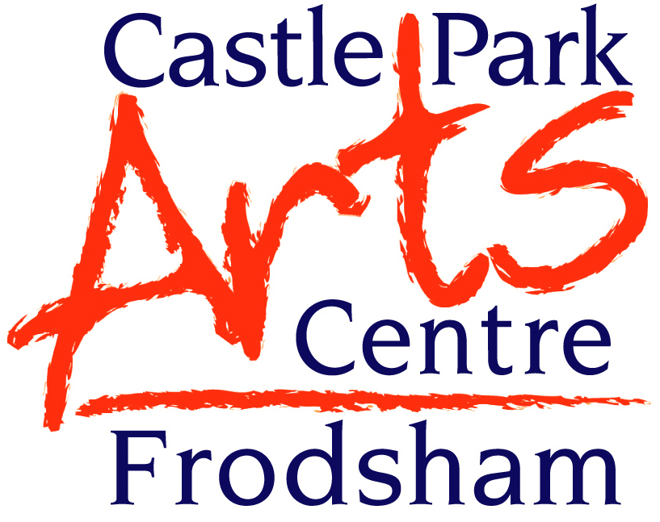
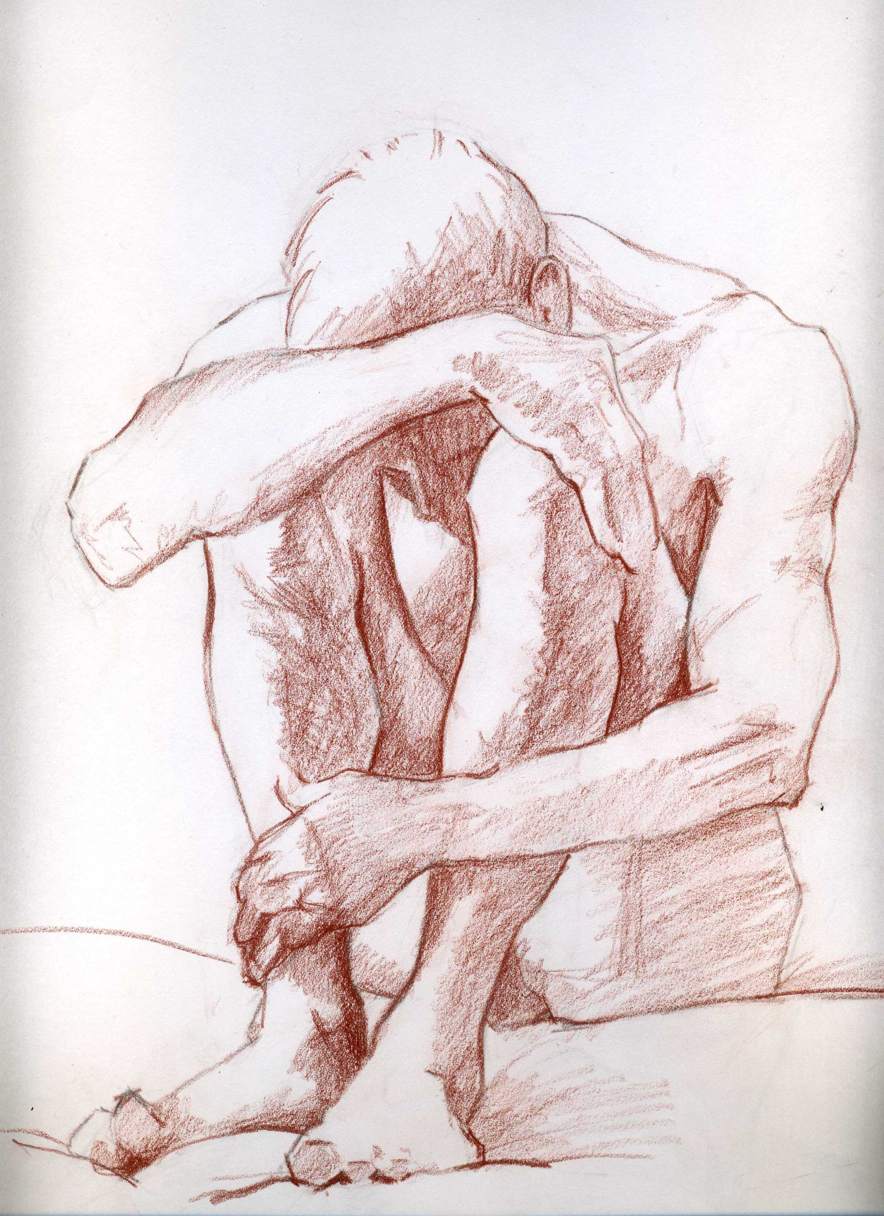

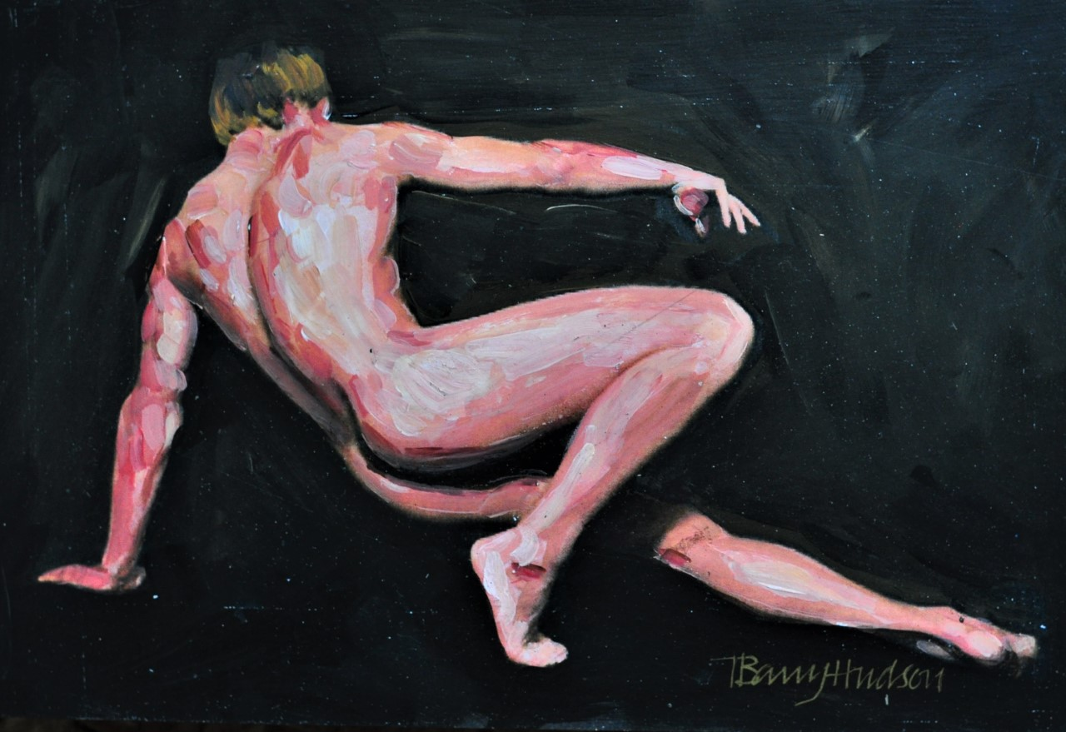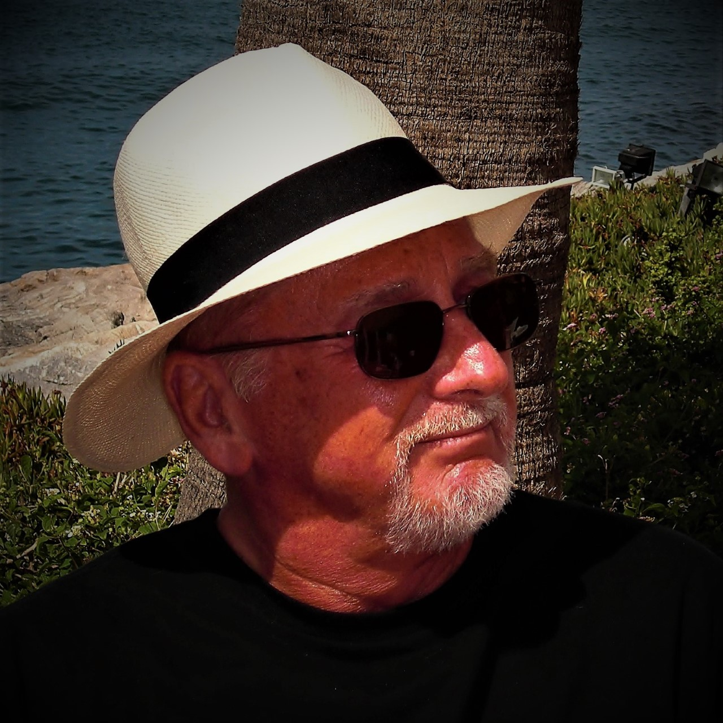

NEW Life Drawing Classes WITH Barry Hudson

Dates when you wish to attend ……………………………………………………………………….

There are two classes run on a Saturday and they are open to all.

TIME: 10.00am – 12 NOON
FEE: £45.00 for 5 week course or £10.00 per session
**************
TIME: 12.30pm- 2.30pm
FEE: £45.00 for 5 week course or £10.00 per session

Please state which session you wish to join – if you wish to ‘drop in’ please ring and let the office know just in case there are no spaces left.

PLEASE COMPLETE THIS SECTION AND FORWARD WITH FEE TO CASTLE PARK ARTS CENTRE, CASTLE PARK, FRODSHAM WA6 6SE
TEL: 01928 735832: kim@castleparkarts.co.uk www.castleparkarts.co.uk

CHEQUES MADE PAYABLE TO: CASTLE PARK ARTS CENTRE/ PAY OVER THE PHONE BY CARD, 01928 735832

CLASS (AM OR PM) …………….………………………………................................................................

NAME…………………………………………..ADDRESS…………..……………………………………

………………………………………………………………….…………………………………………….

TEL NO……………………………………………….……………………………………………….……..

EMAIL ADDRESS………………………….……………………………………………………….………

